Grounding Techniques
Sensory grounding techniques
5,4,3,2,1:
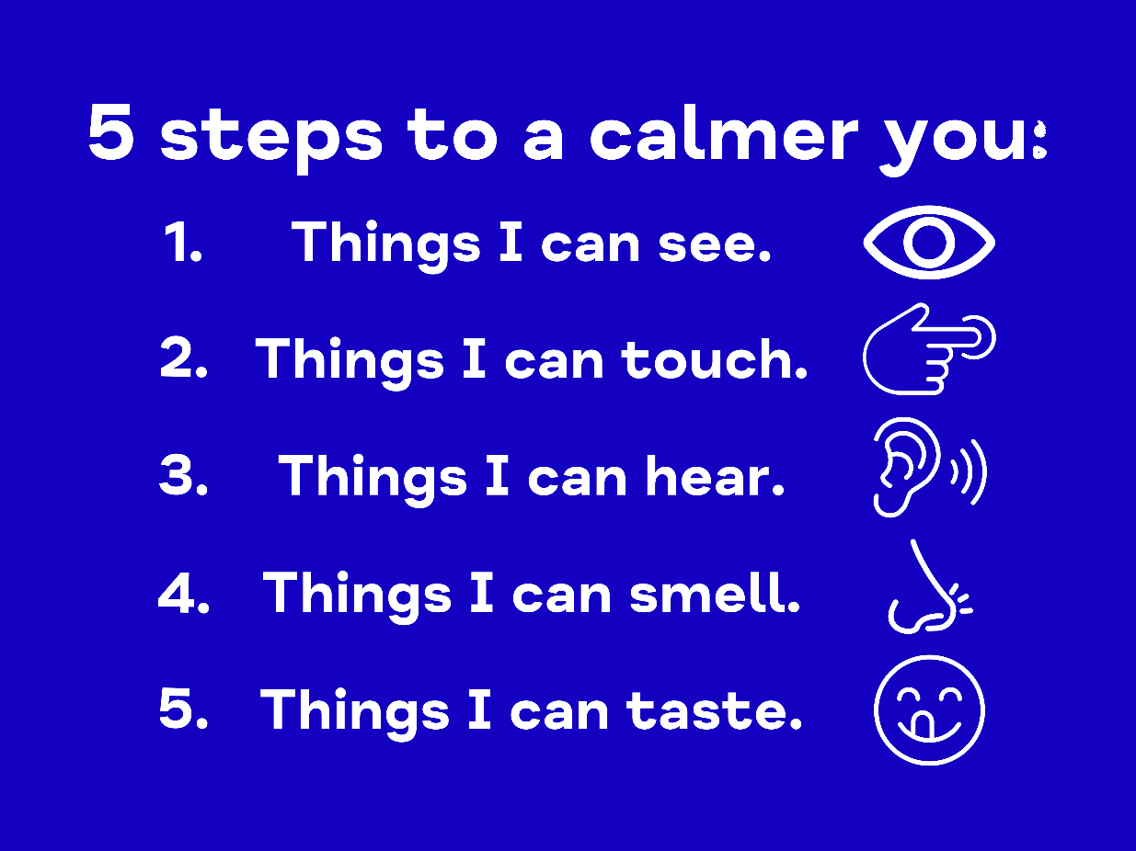
https://insighttimer.com/blog/54321-grounding-technique/

Cold Water Therapy:
https://dbtforlife.com/2020/12/14/explore-dbt-ice-and-anxiety-using-cold-water/

Describe an object:
Hold an object think about what it looks like, how it feels, if it makes any noise, if it has a smell etc.

Breathing techniques
Box breathing:
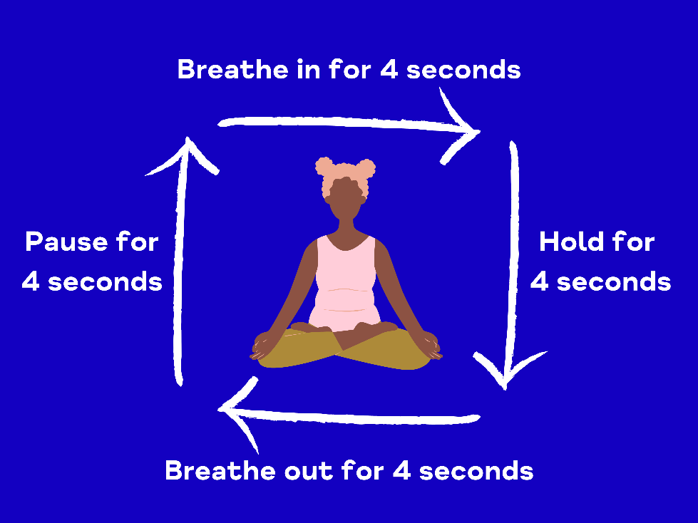
https://www.healthline.com/health/box-breathing#tips-for-beginners

Paced breathing:
https://xhalr.com/

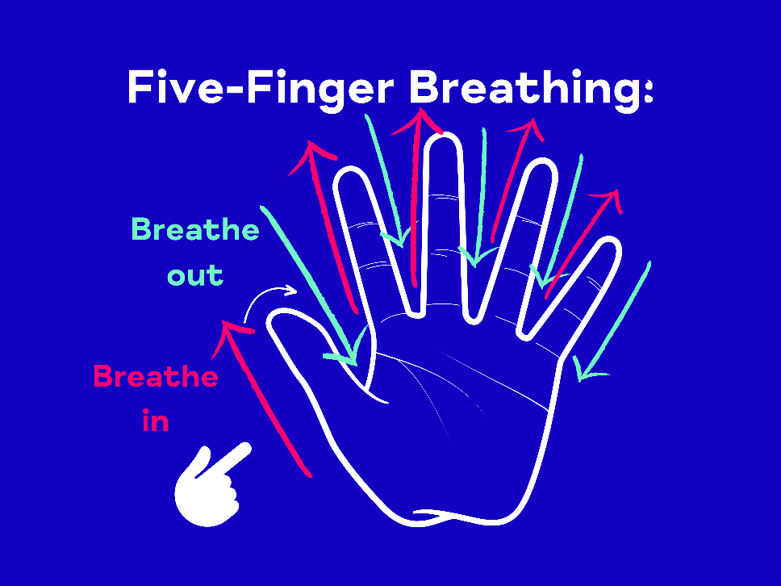
Five-finger breathing:

https://health.clevelandclinic.org/five-finger-breathing/
Body relaxation techniques
Body scan:
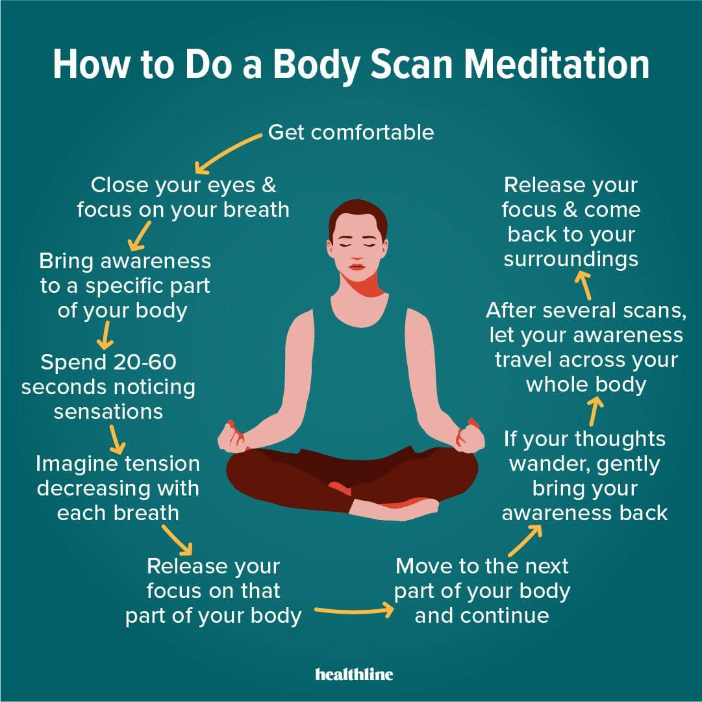

How to Do Body Scan Meditation and Its Benefits (calmsage.com)

Progressive muscle relaxation:
https://relaxation-audio.com/2021/02/22/5-minute-progressive-muscle-relaxation/

