Lived Experience Interviewer
Do you have lived experience of mental health? Would you like to use this to shape the future of Oxfordshire Mind?
Become a Lived Experience Interviewer and support Oxfordshire Mind to recruit the right people, whilst building your own interviewing skills, confidence, and self-esteem.
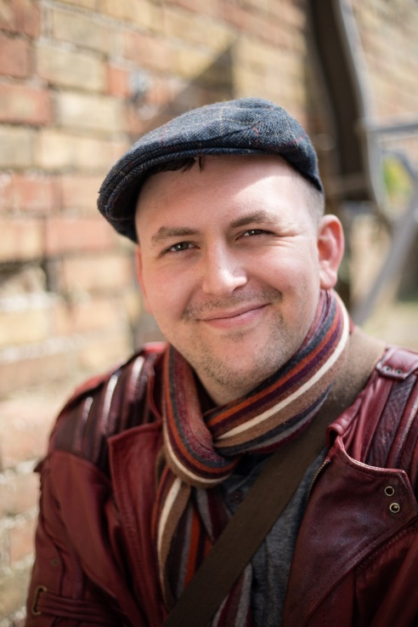
Tasks may include:
- Sitting on interview panels for potential new Oxfordshire Mind workers
- Sitting on virtual interview panels
- Supporting with shortlisting potential candidates
- Participating in other aspects of Oxfordshire Mind’s recruitment process

Time commitment: Flexible.
Location: Remotely and across Oxfordshire.
Skills needed: No previous interviewing experience is required. Interviewers need to be organised, with good communication skills, and able to work within Oxfordshire Mind’s values. For people with lived experience.
Support provided: You will receive training and support around the recruitment process, shortlisting and interviewing.
Application process: Speak to our Service User Involvement Coordinator, paperwork, and completion of training.
Payment: We offer payment and travel expense reimbursement for opportunities.

Get in touch with the Service User Involvement Coordinator today! getinvolved@oxfordshiremind.org.uk / 07776990311

