Expert by Experience
Do you have lived experience of mental health? Have you used Oxfordshire Mind’s services?
Our Experts by Experience use their experience of mental health to raise awareness, challenge stigma, improve services, and talk about the work Oxfordshire Mind does from their expert point of view.
Tasks may include:
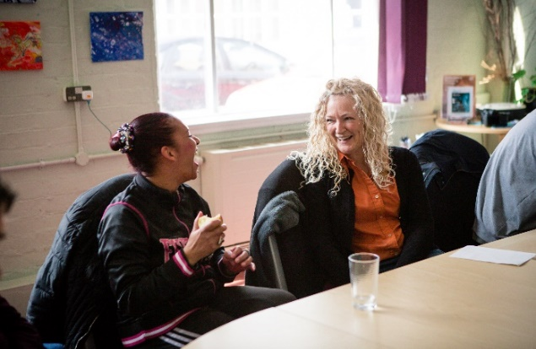
- Sharing your story for social media
- Doing talks at internal and external events
- Attending steering groups with other Local Minds
- Supporting service changes
- Delivering training to staff, volunteers, and members of the public
- Advising on poster and leaflet design
- Quality reviews of services and processes

Time commitment: Flexible. We ask you to attend monthly group supervisions.
Location: Remotely and across Oxfordshire.
Skills needed: Experts need to be organised, with good communication skills, and able to take a recovery focused approach. For people who have used Oxfordshire Mind’s services in the past or currently.
Support provided: Ongoing training, group supervision and individual support.
Application process: Informal interview, Enhanced DBS check and training.
Payment: We offer payment and travel expense reimbursement for opportunities.

Get in touch with the Service User Involvement Coordinator today! getinvolved@oxfordshiremind.org.uk / 07776990311

