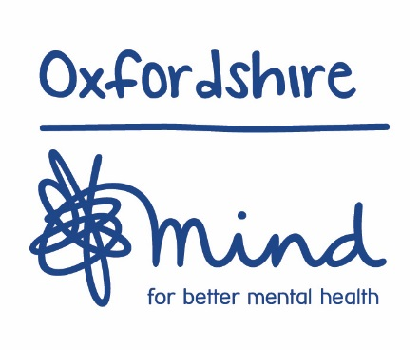
Becoming a member of Oxfordshire Mind

Why become a member of Oxfordshire Mind?
Oxfordshire Mind is all about people. Since we were founded in 1967 we’ve been making sure that anyone in Oxfordshire experiencing a mental health problem gets the right advice and support.
By becoming a member of Oxfordshire Mind you can help us challenge the stigma so often associated with mental health problems, get involved in our campaigns, and celebrate the amazing people who use our services.

How much does it cost?
Membership costs just £5 if you’re unwaged, or £15 if you have a wage. Your membership runs for one year.

What do I get for my membership fee?
As a member you will receive:
- Monthly email updates about our work
- A twice-yearly members’ magazine, packed with behind-the-scenes interviews with staff, volunteers and people using our services
- Invitations to join us at our talks, events and Annual General Meeting
- Free car sticker to let everyone know that you support us.

How do I join?
Just complete the form overleaf and return it to us with a cheque payable to Oxfordshire Mind. If you prefer to sign up online, visit our website at www.oxfordshiremind.org.uk and click on the Join Oxfordshire Mind button.
Please return your form to Membership, Oxfordshire Mind, 2 Kings Meadow, Osney Mead, Oxford OX2 0DP

Section 1: Your contact details
Title Dr Mr Mrs Ms Miss Other ______________________________
Surname ________________________ First name __________________________
Address _____________________________________________________________
Town ___________________________ Postcode ___________________________
Mobile __________________________ Email ______________________________

Section 3: About you
Do you have experience of mental distress personally, or through friends & family?
If yes, please state which: personally friends/ family
Have you used any of Oxfordshire Mind’s services? Yes No
How did you hear about Oxfordshire Mind? _________________________________

Section 4: Membership of Oxfordshire Mind
Please circle your chosen type of membership: Waged (£15) Unwaged (£5)
Cheque (payable to Oxfordshire Mind) is enclosed: Yes No
Gift Aid your membership subscription? Yes No
If I have ticked the box headed ‘Gift Aid? ’, I confirm that I am a UK Income or Capital Gains taxpayer. I have read this statement and want the charity or Community Amateur Sports Club (CASC) named above to reclaim tax on the donation detailed below, given on the date shown. I understand that I must pay an amount of Income Tax and/or Capital Gains Tax in the tax year at least equal to the amount of tax that all the charities and CASCs I donate to will reclaim for that tax year. I understand that other taxes such as VAT and Council Tax do not qualify. I understand the charity will reclaim 25p of tax on every £1 that I have given.

Signed __________________________________ Date _________________
All information will be treated in the strictest confidence and will be used for our administration purposes to assist us with our internal marketing, to create anonymised statistics about our fundraising, or to supply you with further information about Oxfordshire Mind and different ways you may choose to support us. If you would prefer not to hear from us, please tick here

Registration form created 2015. Oxfordshire Mind, 2 Kings Meadow, Osney Mead, Oxford OX2 0DP. Reg charity: 261476.

